**Analyzing Art Observation – Online vs Face-to-face**

**with using an eye-tracker**

Computational Human Behavior Lab 2022

**by :**  Marian Abu Saleh , Yaseen Abd Elhaleem , Michael Mogrman .

BSc. Students at Computer Science Dep, University of Haifa

**Supervised by:**

Prof. Hagit Hel-Or , Prof. Tsvi Kuflik , Prof. Emma Maayan-Penner.

* University of Haifa .

**The focus of the article**

The paper will present an empirical investigation the difference between the way people observe art in museum - where they can see the painting physically and the way they see it on computer screen.

**An outline of the study**

**Study goals**

1. analyzing the participants gaze as they look at the images presented to them and be able to point out where their eyes are looking at any given second on the screen with using eye-tracker.

we used online eye-tracker-calibration by using barcodes in all corners of the image .

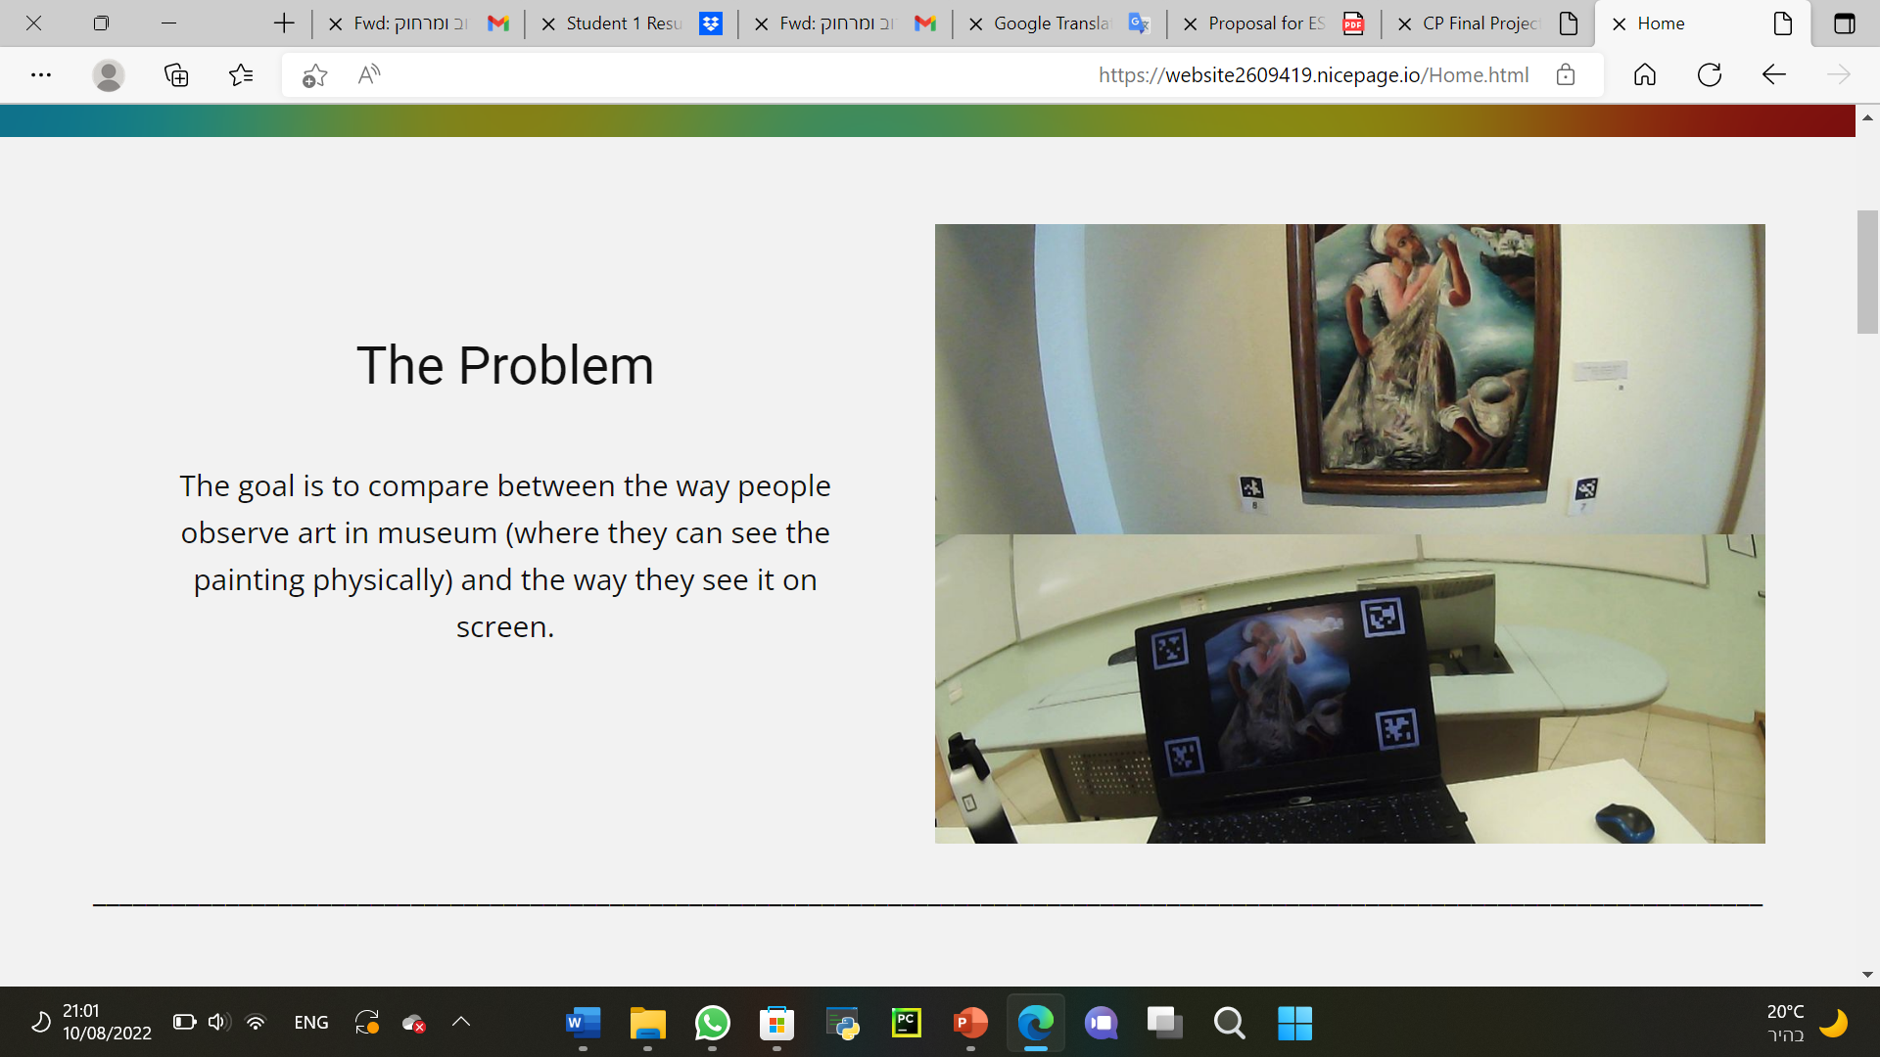

1. The goal is to compare between the way people observe art in museum and the way they see it on screen.

**The Plan**

Our plan was to go with the participants to the museum and film them while they look at 5 different paintings for the first time and then after a while (2 weeks or more) we'd invite the participants again and film them while looking at the same paintings on a computer screen.

After we gather all needed data we'd filter it, analyze it and represent it in different forms (heatmaps, clusters of gazes, etc..) so that we could get results.

**The images we used**

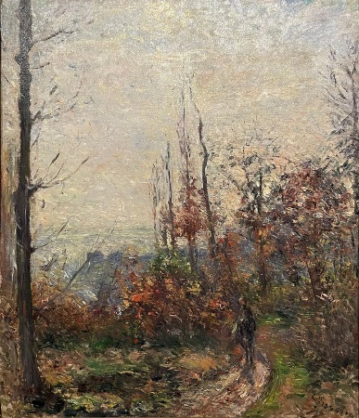 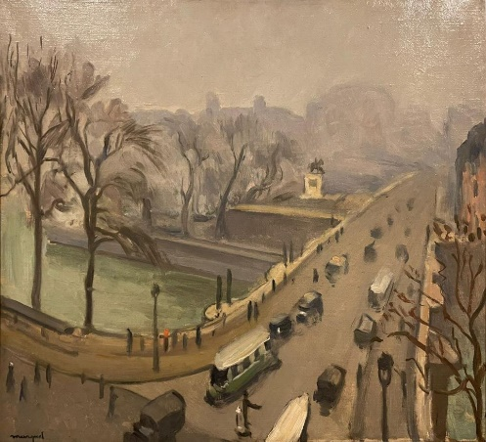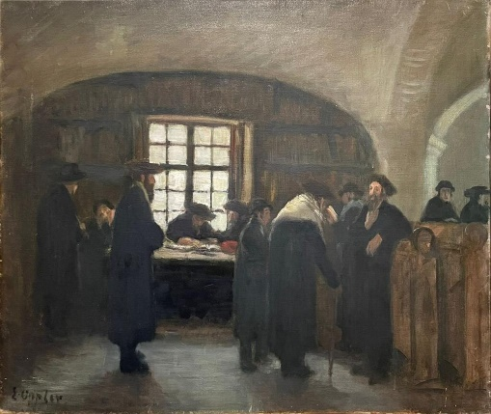

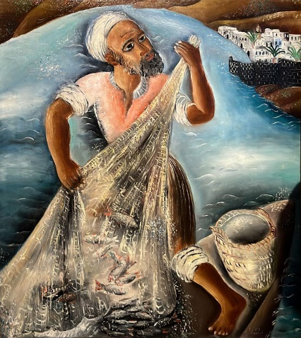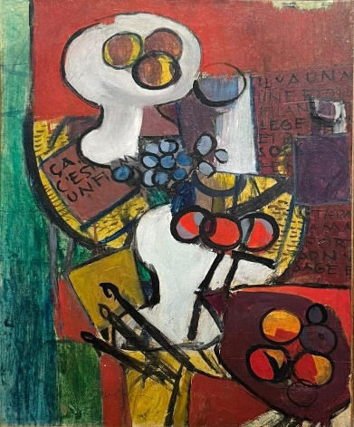

**A Brief Timeline Of Work**

1. Choose the art piecies which our participants will look at , (5 paintings were chosen).
2. Gather participants.
3. Film with participants at the museum.
4. Film with participants on computer screen (2 weeks later).
5. Filter the data we got and trying to represent it as informative as we could.
6. Concluding results from the data.

**The method**

We used the [Pupil Core eye tracker](https://docs.pupil-labs.com/core/) to gather data of where each subject was looking at the painting, we had a protocol to work by for filming:

1. Gather details of the participants (including stuff that would help to conclude results, like: "do you paint?").
2. Calibrate the eye tracker (for each participant and each one of the 5 paintings).
3. Reveal the painting and start filming (we hid the paintings in advance so that we could record the first seconds of observing the art piece).

**Information on eye tracking used in the study**

We use the Pupil eye tracker by Pupil Labs GmbH for pervasive eye tracking and gaze-based interactions. The data was collected using the eye tracker worn by participants during they looking at the pictures. The eye tracking data provides the eye motion pattern for each participant, in each of the tasks. The eye tracker outputs a sequence of locations (x,y coordinates) within the participants’ field of view at every time step. The eye tracker also provides pupil size at each time step (brightness of the displays will remain constant in all tasks). This data is translated into 3 forms of data:

a) Characteristics of the eye motion itself, including the number, frequency and length of the saccades as well as distribution of directions.

b) Location of fixations, namely, the number of visits, and length of visits of the different specific regions of the task description.

c) Temporal data on the ordered sequence of fixation locations. This data can be represented as a directed graph representation, weighted Markov chain or transition matrix.

**Data representation**

**Heat Map**

A heat map is a data visualization technique that shows magnitude of a phenomenon as color in two dimensions. The variation in color is by hue and intensity, giving obvious visual cues about how the phenomenon is clustered or varies over space.

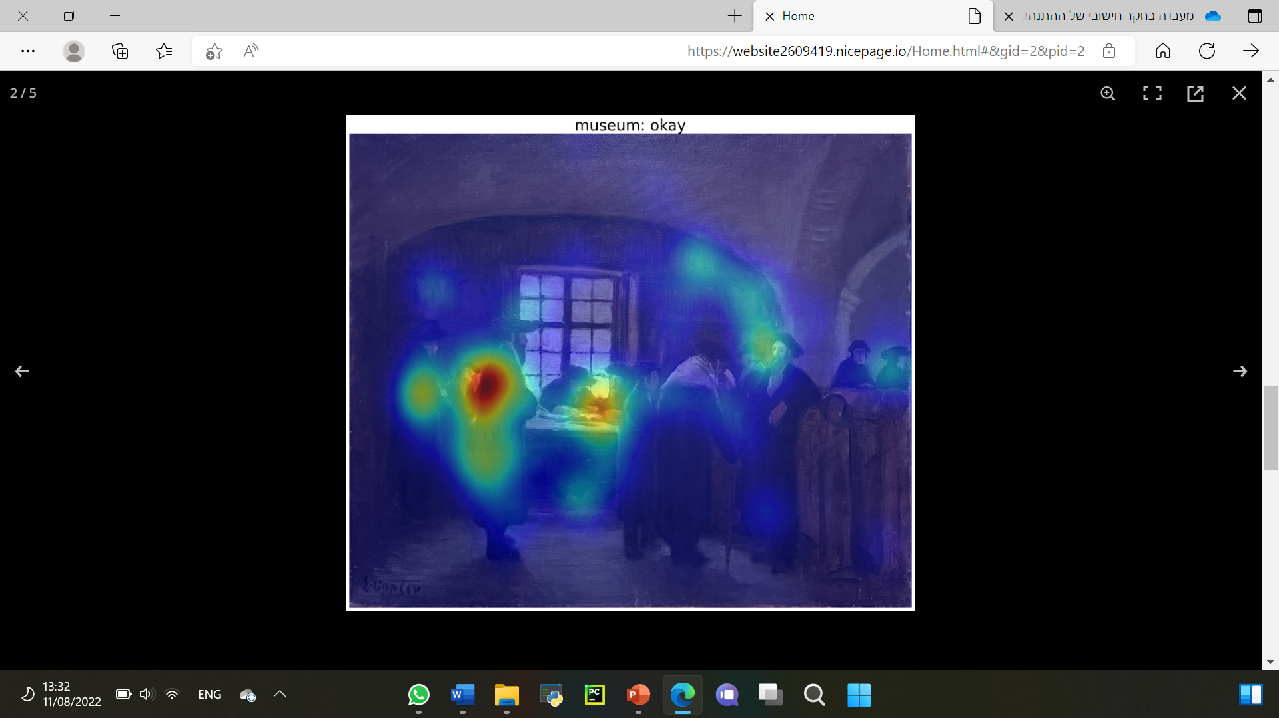 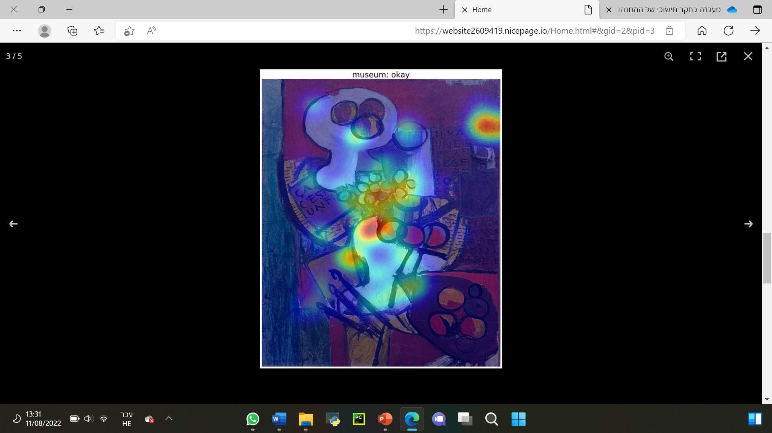

**Clusters**

k-means clustering is a method of vector quantization, that aims to partition n observations into k clusters in which each observation belongs to the cluster with the nearest mean.

For each image we presented the k-means clustering for 30 seconds.

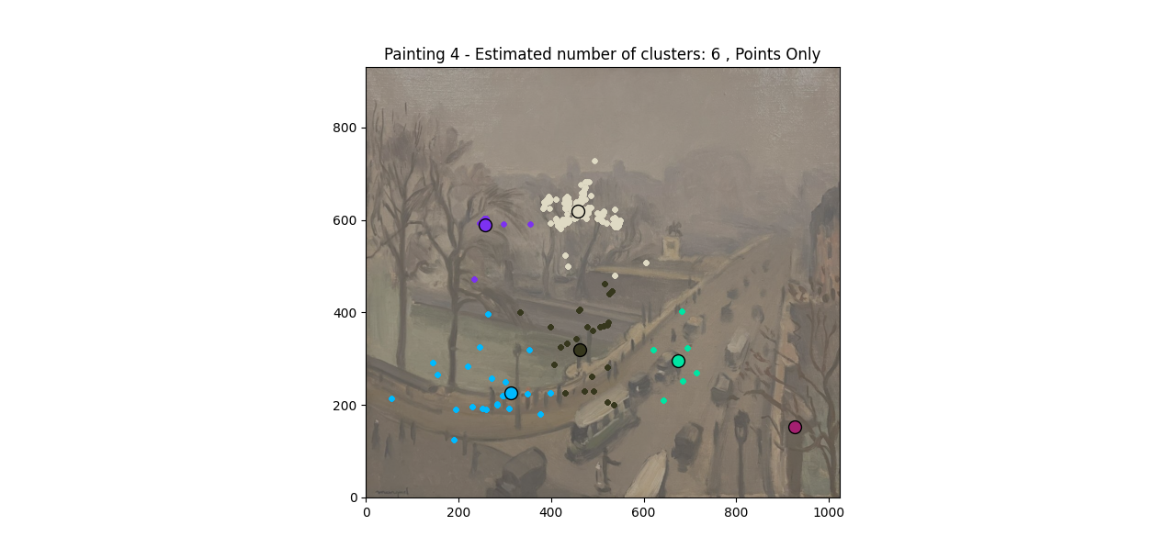 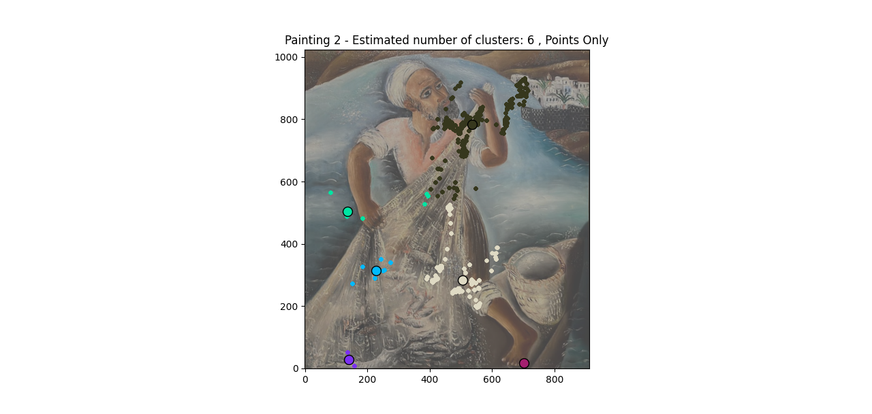

**Histogram Cluster**

In this table we show the size of the observation in each area.

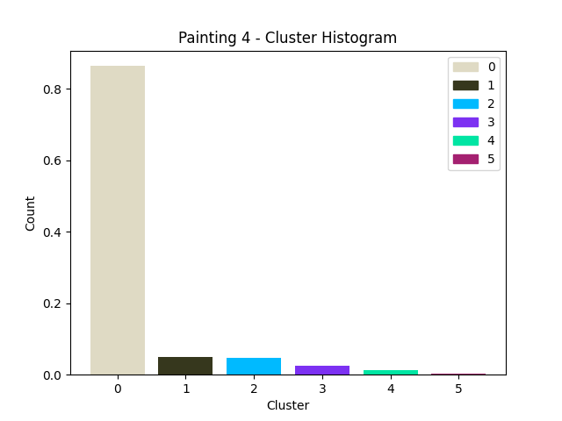 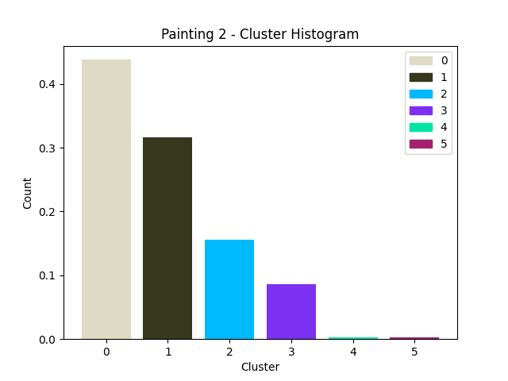

**Transition Matrix**

The cell [i, j] in the matrix contains the number of times the participants looked at zone i and then moved straight to zone j.

* The center of the clusters are the regions we want to see how many times the participant passed her gaze between.

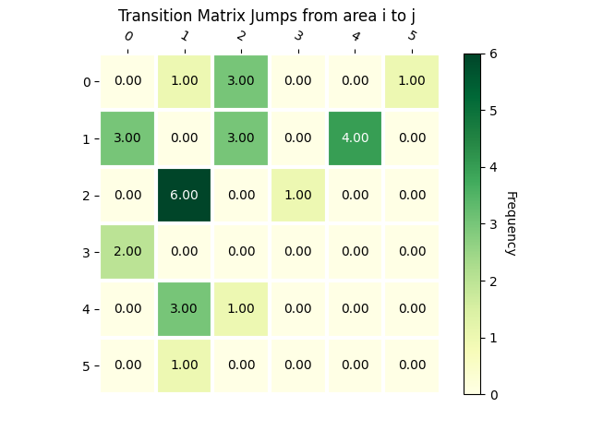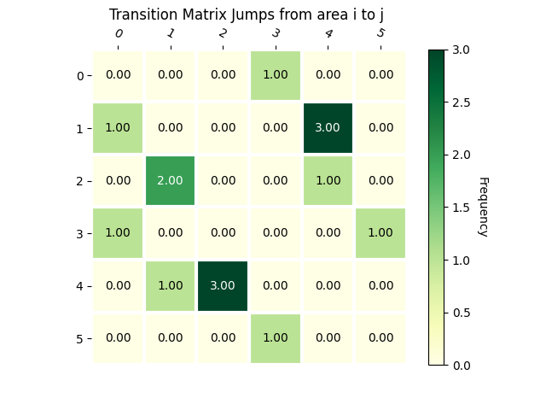

* Also we show the transition between areas in arrows, the size of arrows symbolizes how many times the participant moved from one area to another.

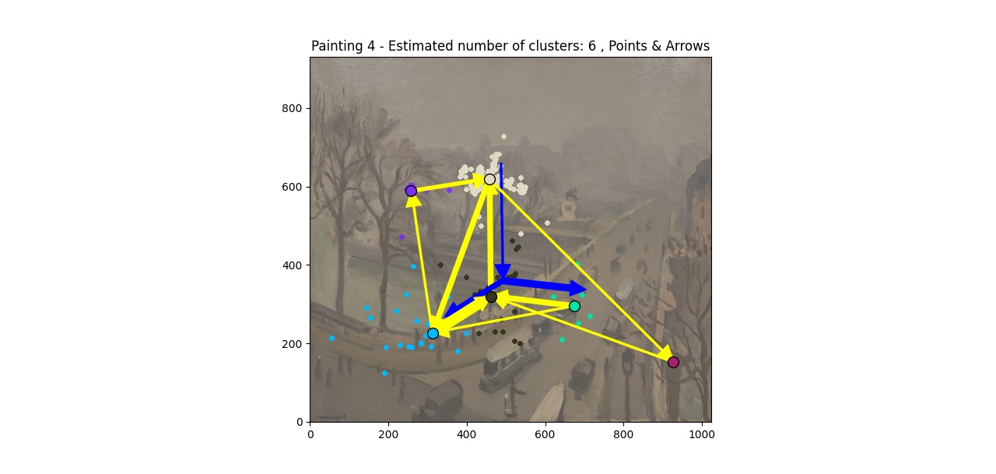 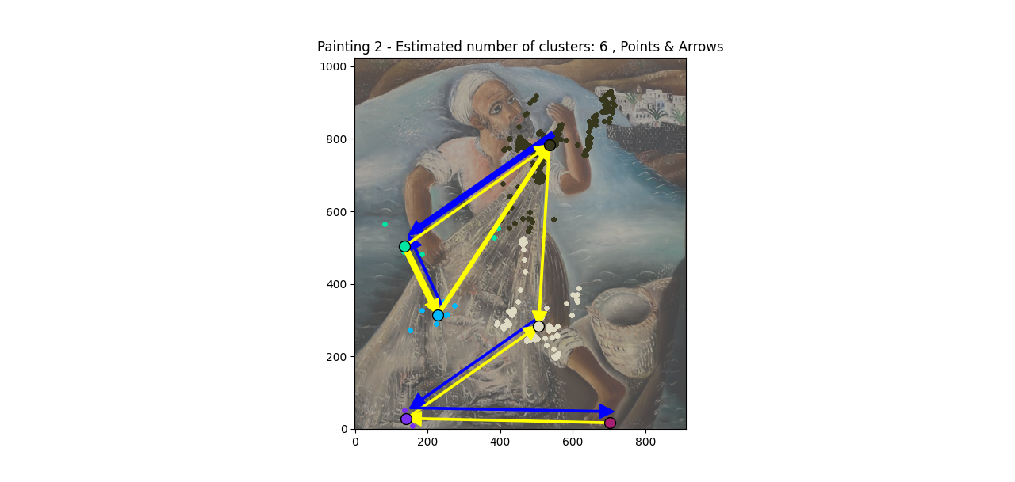

**Scan-Paths**

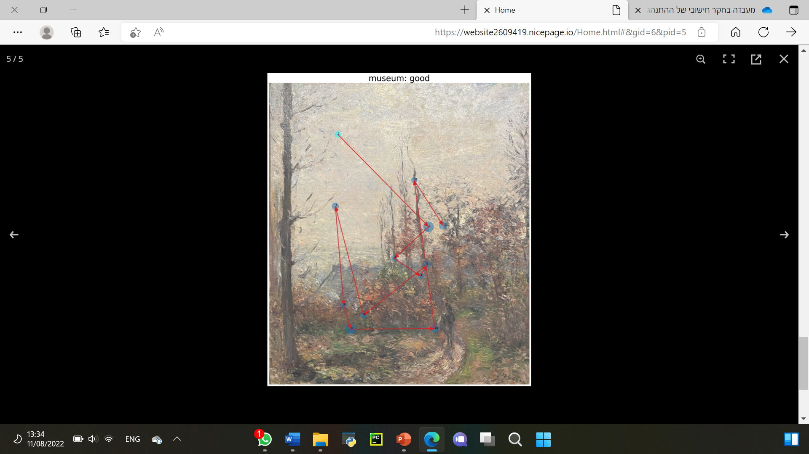 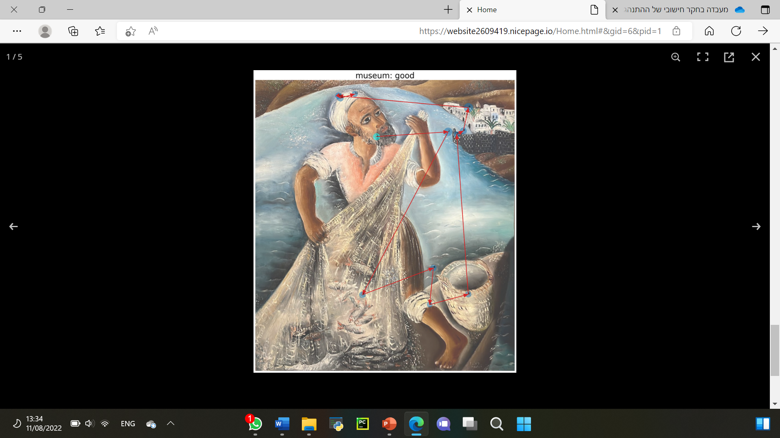

**Results**

By using the functions, we wrote in PYTHON we calculated all the gaze points on the pictures we presented to the participant.

We made a comparison between the results of the first part – in museum and the second part – in computer screen.

in museum :



in computer screen :

